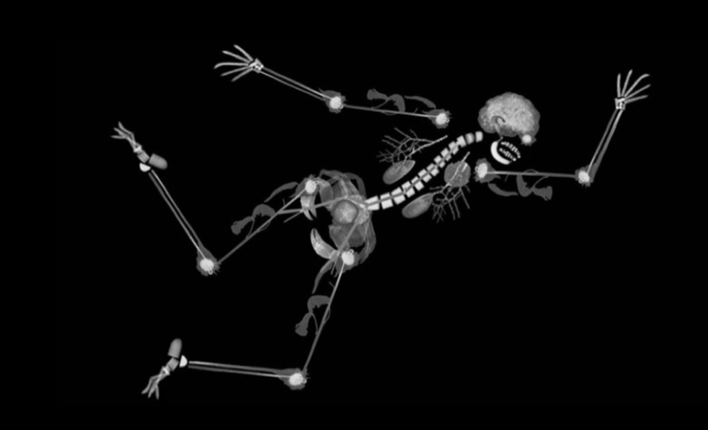  Norwich Interventional Radiology  Image Guided Intervention-for beginners  This one-day course is aimed at ST1-3 trainees in radiology  Our course is run by a group of experienced interventional radiologists and involves observing a live case, attending practical sessions and short talks. This is also a great opportunity for trainees to ask questions on how to get into IR.  What we cover?  - Observing a live/ recorded case  - Case based simulator experience in endovascular procedures  - Hands on US guided procedures using phantoms  - Discussion of tools and kit used in image guided procedures.  - Short talk and discussion on how to get into IR | Save the date!!!  15th of March 2021  The course is limited to 12 spaces to ensure adequate hands-on experience  Venue  East of England Imaging Academy  Time: 08:30-17:00  Cost  £100  (£40, reimbursed on attendance, for EOE trainees)  Course organisers  Dr Kelvin Tan  Dr Tariq Ali  Faculty  TBC

