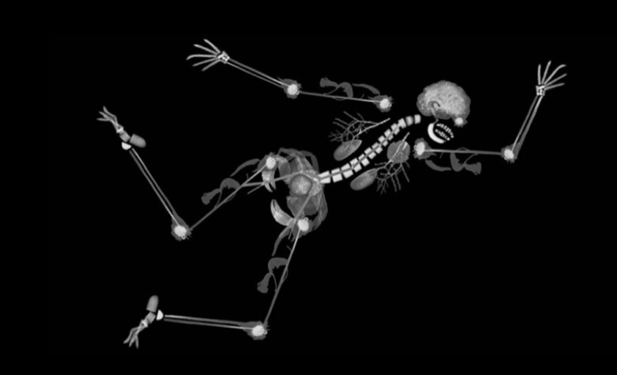

Norwich Interventional Radiology

Image Guided Intervention – for beginners

Course overview: This course aims to teach and reinforce the basics of the tools used and skills needed in interventional radiology. It is aimed at ST1-3 trainees in radiology who wish to develop their skills in performing basic procedures and for those who wish to apply for training in interventional radiology.

Aim: To teach and reinforce the basics of the tools used and skills needed in interventional radiology

We utilise a state of the art Mentice simulator (VIST-LAB with VIST G5) and different physical models. In addition, there will be an industry supported Symbionics EVAR simulator.

Objectives:
- To provide insight into a standard IR case by observing a live procedure via video link
- Know the steps involved in performing endovascular procedures using a simulator
- Know how to perform US guided procedures using phantoms
- Know the tools and kit used in IR and image guided procedures
- Know how to tailor your CV to get into interventional radiology

