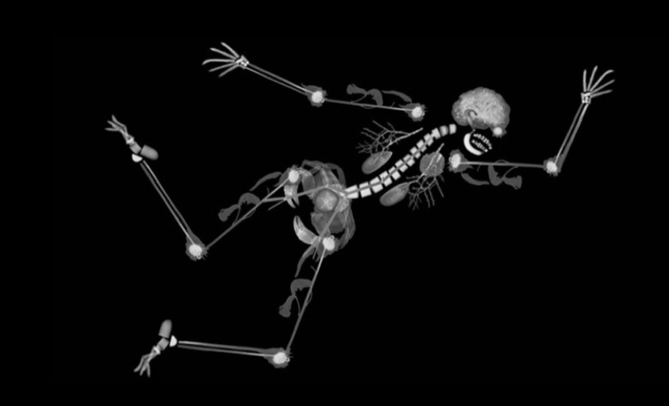

Norwich Interventional Radiology

Advanced Endovascular Workshop

Course overview: This brings together experts in aortic and peripheral vascular interventions. The course aims to teach and reinforce the principles of planning and performing aortic and peripheral vascular interventions. It is aimed at IR and vascular surgical trainees who have a basic understanding of vascular interventions and who wish to develop their skills in planning and performing standard EVAR and complex peripheral vascular interventions. The course combines lectures with extensive opportunity for hands on practise with simulators.

We utilise a state of the art Mentice simulator (VIST-LAB with VIST G5) and different physical models. In addition, there will be an industry supported Symbionics EVAR simulator.

Aim: To teach and reinforce the principles of planning and performing aortic and peripheral vascular interventions

Objectives:
- To provide insight into a complex peripheral vascular case by observing a live procedure via video link
- Know and demonstrate the steps involved in performing endovascular procedures using a simulator (angioplasty, stenting and EVAR) & how to deal with complications
- Know how to interpret CT angiograms and its use in EVAR case planning
- Know the tools and kit used in endovascular procedures
- Learn ‘tips and tricks’ on how to deal with difficult cases

