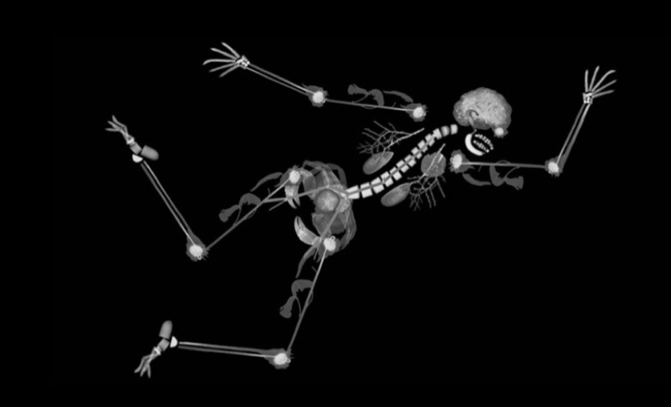  Norwich Interventional Radiology  Advanced Endovascular Workshop  This one-day course is aimed at IR and Vascular surgical trainees  Our course is run by a group of experienced interventional radiologists and vascular surgeons involving live case demonstration, practical sessions and short talks.  What we cover?  - Live/ recorded case demonstration  - Case based simulator experience in endovascular procedures (angioplasty, stenting and EVAR)  - CT Angiogram interpretation and EVAR planning  - Discusison on tools and kit used in endovascular procedures.  - Tips & tricks in difficult cases. | Save the date!!!  16th of March 2021  The course is limited to 8 spaces to ensure adequate hands-on experience  Venue  East of England Imaging Academy  Time: 08:30-17:00  Cost  £ 100  (£40, reimbursed on attendance, for EOE trainees)  Course organisers  Dr Tariq Ali  Dr Kelvin Tan  Faculty  tbc

